**DAILY ONLINE ACTIVITIES SUMMARY**

|  |  |  |  |  |  |  |  |  |
| --- | --- | --- | --- | --- | --- | --- | --- | --- |
| **Date:** | **19/06/2020** | | | | | **Name:** | **Anjali Manohar Prabhu** | |
| **Sem & Sec** | **4th Sem Section - ‘A’** | | | | | **USN:** | **4AL18CS007** | |
| **Online Test Summary** | | | | | | | | |
| **Subject** | | **MICROCONTROLLER AND EMBEDDED SYSTEM** | | | | | | |
| **Max. Marks** | | **20** | | **Score** | | | **20** | |
| **Certification Course Summary** | | | | | | | | |
| **Course** | **MICROSOFT AZURE ESSENTIAL** | | | | | | | |
| **Certificate Provider** | | | 1. **Great Learning Academy** | | **Duration** | | | **11.0hrs** |
| **Coding Challenges** | | | | | | | | |
| **Problem Statement:**   1. Write a C program to count total set bits in all numbers from 1 to n. | | | | | | | | |
| **Status: executed** | | | | | | | | |
| **Uploaded the report in Github** | | | | | **YES** | | | |
| **If yes Repository name** | | | | | [**https://github.com/vinisharen/lockdown-coding**](https://github.com/vinisharen/lockdown-coding) | | | |
| **Uploaded the report in slack** | | | | | **YES** | | | |

Online Test Details: MES test was conducted on 19/06/2020 from 3:00 pm to 3:30 pm. There were 20 question and the questions were MCQ types and the portion was “MODULE 4”. Each question consisted of 1 marks each and the marks that I scored was 20/20.

SNAPSHOT: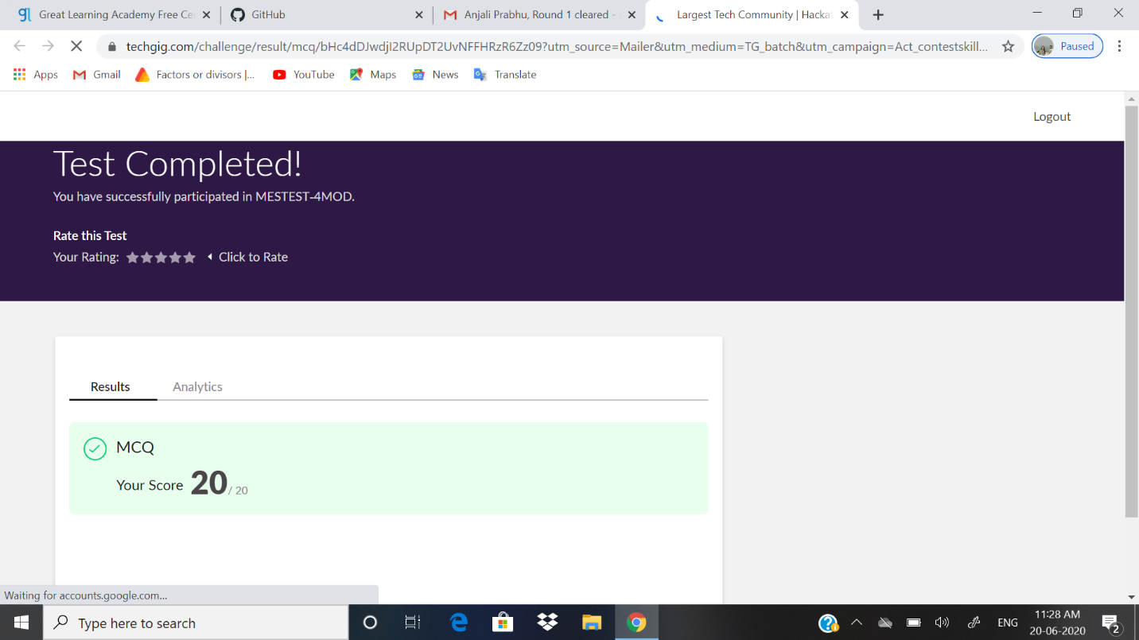

Certification Course Details: **Microsoft Azure**, commonly referred to as **Azure** ([/ˈæʒər/](https://en.wikipedia.org/wiki/Help:IPA/English)), is a [cloud computing](https://en.wikipedia.org/wiki/Cloud_computing) service created by [Microsoft](https://en.wikipedia.org/wiki/Microsoft) for building, testing, deploying, and managing applications and services through Microsoft-managed [data centers](https://en.wikipedia.org/wiki/Data_center). It provides [software as a service (SaaS)](https://en.wikipedia.org/wiki/Software_as_a_service), [platform as a service (PaaS)](https://en.wikipedia.org/wiki/Platform_as_a_service) and [infrastructure as a service (IaaS)](https://en.wikipedia.org/wiki/Infrastructure_as_a_service) and supports many different [programming languages](https://en.wikipedia.org/wiki/Programming_language), tools, and frameworks, including both Microsoft-specific and third-party software and systems.

Azure was announced in October 2008, started with codename "Project Red Dog",[[1]](https://en.wikipedia.org/wiki/Microsoft_Azure#cite_note-1) and released on February 1, 2010, as **Windows Azure** before being renamed to Microsoft Azure on March 25, 2014.

**SNAPSHOT:**

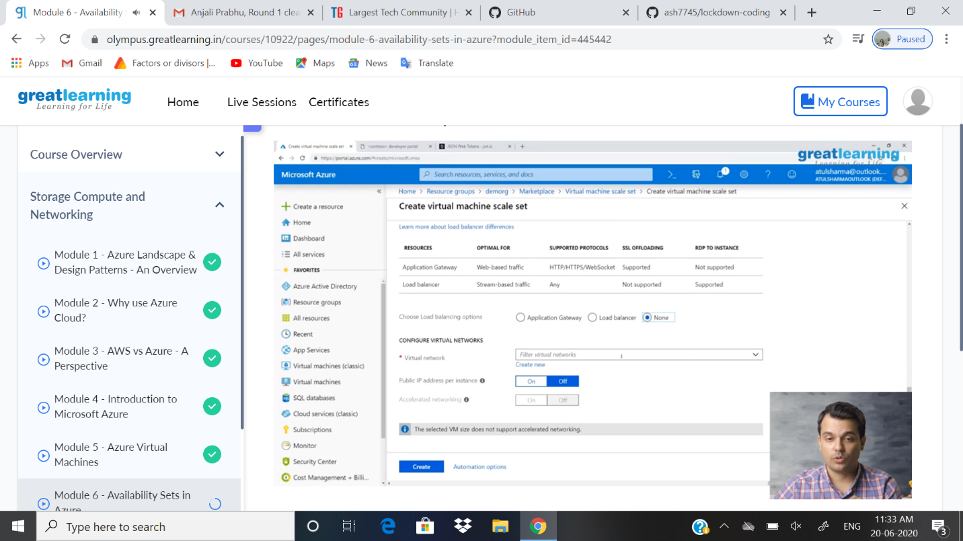

ONLINE CODING DETAILS:

PROBLEM 1: Write a C program to count total set bits in all numbers from 1 to n.

SNAPSHOT: 